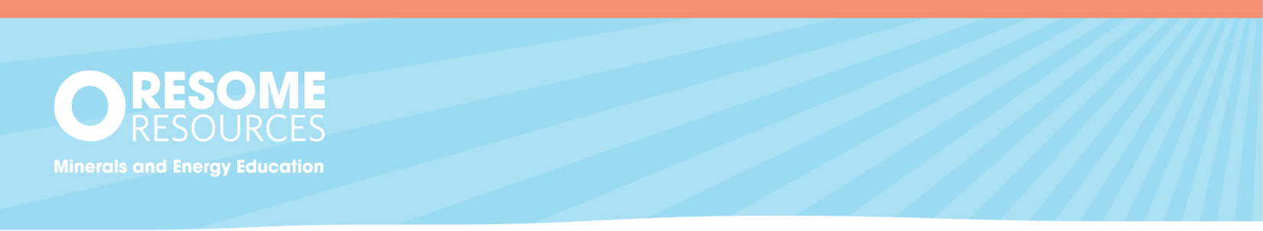
Worksheet 1 – Rehabilitation Animation

Worksheet 1
– Rehabilitation Animation

Questions
- What job do you think Arlia’s dad does?

- Why do you think the community is involved in deciding what the rehabilitated mine site will be used for?

- What would your favourite option for a mine rehabilitation be?

Suggested Answers
- Arlia’s dad could be an environmental scientist or engineer. He could also be involved in landscaping and land management. Responses should focus on a career that involves the environment or land management. Depending on the student’s prior knowledge, they may also have suggestions such as a manager or human resources.

- Community involvement is very important as it allows the community to be actively involved in how the old mine site will be rehabilitated. The community can work with the mine owners to decide the best fit for their local population. Responses should focus on the key ideas of communities having a voice in the decisions of how to rehabilitate the mine for everyone.

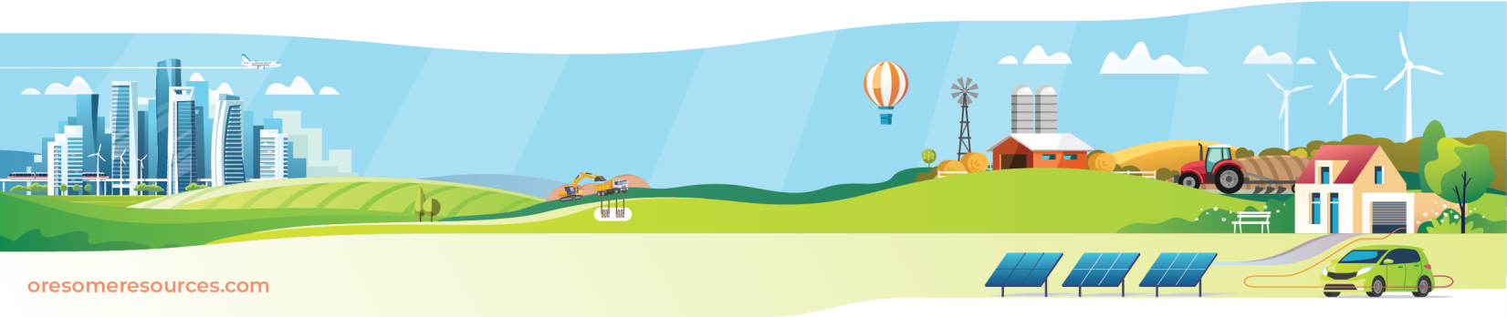
- Responses will vary. The video included bush land, farm land, motorsport, lakes, pumped hydro facility. Students may choose something else they find interesting from their own background knowledge.

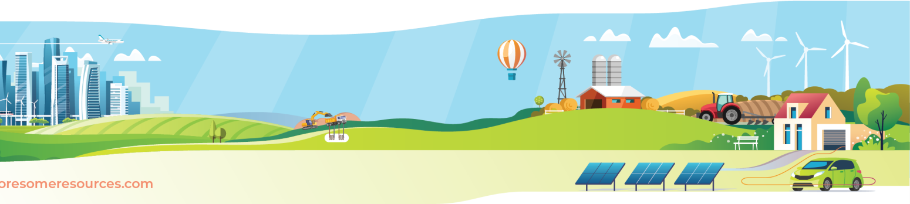
PAG

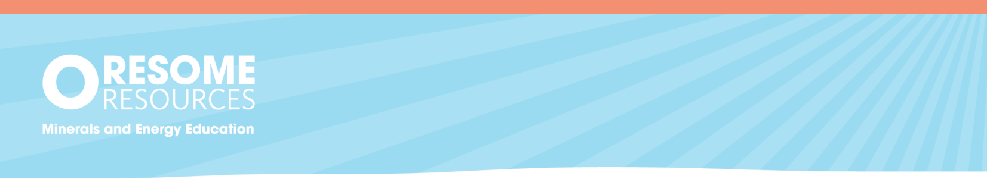
Worksheet 2 – Research Task: Adaptable for all year levels

Worksheet 2 – Research Task: Adaptable for all year levels
There are many examples of successful mine site rehabilitation projects around the world and in Australia. Each of these projects will look different depending on the goals for rehabilitation. Your task is to find a rehabilitation project in your state and research the type of mining that was completed there and the choice for rehabilitation project. You will find examples included in the background text.

Stage One – RESEARCH
  - Start with the state you live in.
  - Go to your internet browser and search using the prompt – what examples of mine rehabilitation are there in INSERT STATE?
  - Decide which mine rehabilitation project you will write about. Answer the following questions using the Research Task Template to support your planning and research. Make sure you take note of the websites you use. Copy any key content and ideas and then write it in your own words. Find a few different websites with different perspectives to ensure your report is well informed.
    - What is the name of the mine?
    - What mineral was mined there?
    - What product is the raw mineral turned into?
    - When did the mine close/intend to close?
    - What rehabilitation is planned/completed for the site?

Stage Two – REPORT WRITING
  - Your report will have three main sections: introduction, body, and conclusion.
  - Using your completed research table, start summarising the information into your own words. Add references where required.
  - Once you have written a paragraph in response to each question, you have completed the body of your report.
  - Finish by adding an introduction and conclusion to the research report.

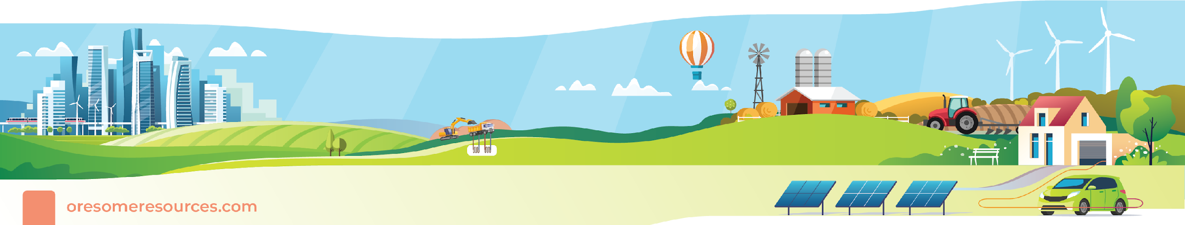
PAG
PAG

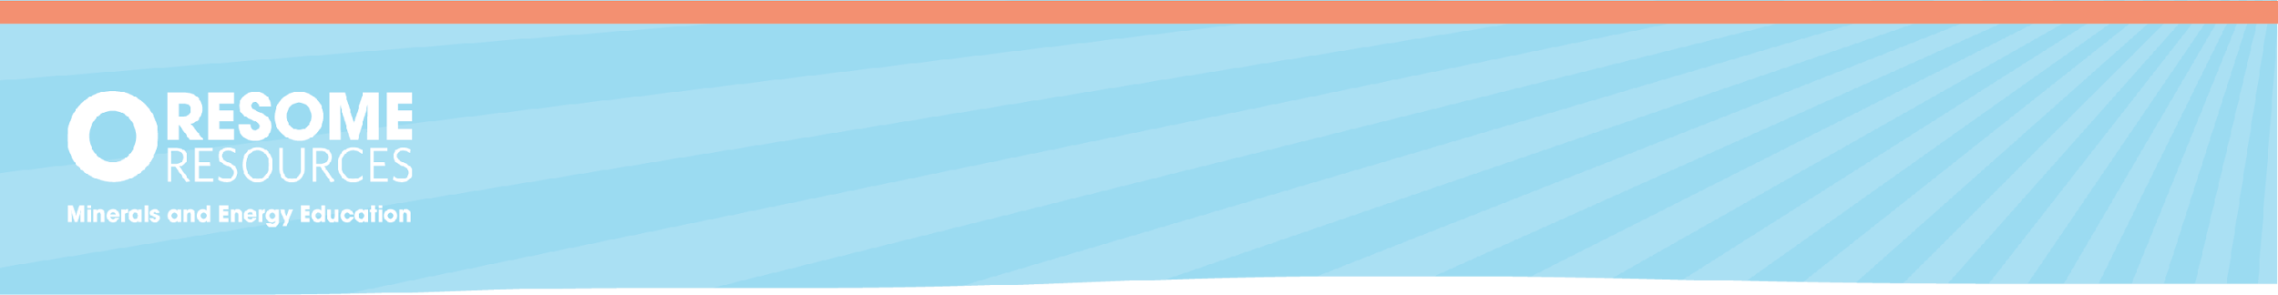
Research Task Template

Worksheet 2 – Research Task: Adaptable for all year levels

Stage One Research Question | Stage One Website/Reference | Stage One  Content Copy and Paste | Stage Two  Paragraph (in your own words)
What is the name of the mine?
What mineral was mined there?
What product is the raw mineral turned into?
When did the mine close/intend to close?
What rehabilitation is planned/completed for the site?

Rehabilitation – Past and Future - Everyone’s Responsibility
In Australia, mining for minerals began over 60,000 years ago with First Nations people mining ochre for paints, and flint and stones for tools and weapons. As early as 6,000 years ago the ancient Sumerians were mining for ores and using smelting techniques (extracting metals from ore using heat) to make bronze tools. Fast forward to now and Australia has over 350 operating mines producing 19 useful minerals for local and export use in an area occupying less than 0.1% of Australia’s land mass.
However, as operating mines come to the end of their life, mine rehabilitation is crucial for ensuring that mine sites are restored to a state that is suitable for environmental conservation or for other commercial uses as determined by the local community such as cattle grazing.
Depending on when the mine site was first commissioned, existing plans or new plans for rehabilitation are used to ensure the site is rehabilitated.
Rehabilitation of a mine site is done in stages and can take many years to complete; planning is started even before the mine site is in operation. Before mining begins, an assessment of the area is completed, including a survey for environmental information, and detailed rehabilitation plans are developed based on the findings. During the mining phase, progressive rehabilitation is often carried out to minimise the impact of mining operations, including replanting native flora. After mining operations cease, the soil, water, and air are remediated, and the land is revegetated. Plant selection will depend on agreed post mining use
There are many examples of rehabilitated mine sites across Australia. The list below provides just a few examples of completed, continuing, and future rehabilitation projects with a range of post-rehabilitation uses including return to natural bushland with native flora, new tourist adventures, motorsports parks, pumped hydro energy storage, grazing farmland for livestock, and lakes to promote watercraft and wetlands.

New South Wales – Rhondda Colliery, a former coal mine in Lake Macquarie, is transforming into a motorsport park and racing track. Black Rock Motor Sport Park will become a multimillion-dollar motorsport resort which will see the land rehabilitated, and the unique shape of the terrain used to host a range of motorsports. The first stage of the park is due to open in 2025.

Northern Territory – Ranger Mine, Australia’s longest running uranium mine, is a rehabilitation project in action. The goal of the rehabilitation plan is to return the mine to a natural state like the surrounding Kakadu National Park. Closure criteria of the mine have been developed and include requirements for landforms, radiation, water and sediment, ecosystems, soils, and culture. These requirements must be met before rehabilitation is considered complete.
Queensland – Kidston Gold Mine in Far North Queensland is being converted into a pumped storage hydroelectric facility. In a world-first, the disused open cut pits will be used to hold water for energy storage. The pumped storage power plant will have a 250 MW capacity and will supply electricity into the national electricity market through a new 275 kV transmission line.
South Australia – Leigh Creek Coal Mine in the Flinders Ranges is currently being rehabilitated and is the proposed site of a new urea plant, pending government approval. Once operational, this repurposed site will be used to produce the nitrogen-based fertiliser for local and export agricultural markets.
Victoria – Central Deborah Gold Mine in Bendigo has been turned into a popular tourism experience, allowing a look into the history of gold mining in the area. Within the Stawell Gold Mine, the Stawell Underground Physics laboratory (SUPL) is making use of the tunnels more than 1km below the surface for dark matter research. This depth allows scientists to explore the world of dark matter with smaller interference of surface radiation on their experiments.
Western Australia – Collie Coal Basin has been a central coal hub for over a century. Lake Kepwari is a man-made lake and former open cut coal mine. Lake Kepwari has become a spot for water skiing and aquatic entertainment. Alongside the lake, over 60 species of native vegetation was seeded to restore the area. This has enabled the local flora and fauna to thrive and the ecosystem to recover.

Further information can be found using these keywords in your internet search.

Key Words
Mine rehabilitation
Old mine usage
Mine sustainable practice
Pumped hydro energy storage
Black Rock Motor Sport Park
Kidston Gold Mine
Rum Jungle Uranium Mine
Renewable energy storage
Gold mining tourism
Stawell Underground Physics Laboratory
Lake Kepwari

Rehabilitation

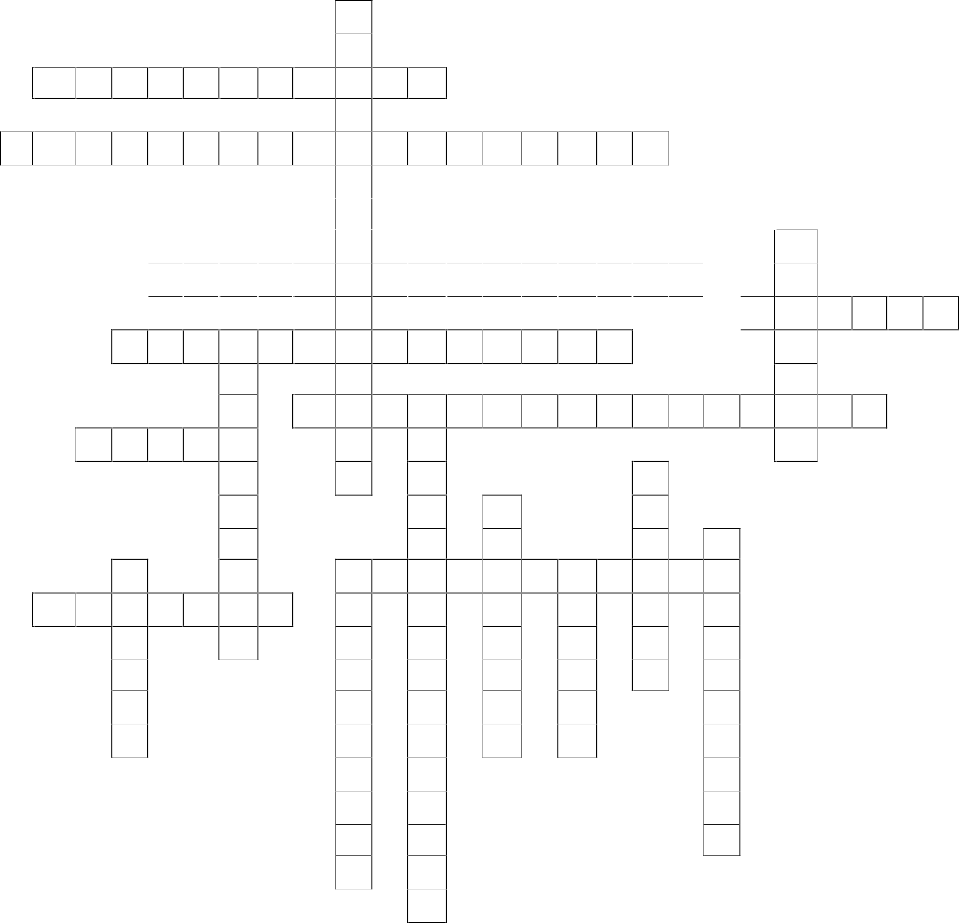
1

2

3

8 9
4
5
6
7

10 11

12

13

14

15

16 17 18

19

Rehabilitation

1
R
 |  |  |  |  |  |  |  |  | H
 | 2 N | A | T | I | V | E | F | L | O | R | A
 |  |  |  |  |  |  |  |  | N
3  T | W | O | H | U | N | D | R | E | D | A | N | D | F | I | F | T | Y
 |  |  |  |  |  |  |  |  | D
 |  |  |  | 4 C | E | N | T | R | A | L | D | E | B | O | R | A | H
 |  |  |  |  |  |  |  |  | C |  |  |  |  |  |  |  |  |  |  |  | 5  S
 |  |  |  | 6  K | I | D | S | T | O | N | G | O | L | D | M | I | N | E |  |  | T
 |  |  |  |  |  |  |  |  | L |  |  |  |  |  |  |  |  |  |  | 7  K | A | K | A | D | U
 |  |  | 8  R | E | H | 9  A | B | I | L | I | T | A | T | I | O | N |  |  |  |  | W
 |  |  |  |  |  | S |  |  | I |  |  |  |  |  |  |  |  |  |  |  | E
 |  |  |  |  |  | S |  | 10  W | E | S | 11  T | E | R | N | A | U | S | T | R | A | L | I | A
 |  | 12  O | C | H | R | E |  |  | R |  | R |  |  |  |  |  |  |  |  |  | L
 |  |  |  |  |  | S |  |  | Y |  | A |  |  |  |  |  | 13  B
 |  |  |  |  |  | S |  |  |  |  | N |  | 14  S |  |  |  | E
 |  |  |  |  |  | M |  |  |  |  | S |  | M |  |  |  | N |  | 15  C
 |  |  | 16  R |  |  | E |  |  | 17  P | U | M | P | E | D | 18  H | Y | D | R | O
 | 19  G | R | A | Z | I | N | G |  | H |  | I |  | L |  | U |  | I |  | L
 |  |  | N |  |  | T |  |  | Y |  | S |  | T |  | N |  | G |  | L
 |  |  | G |  |  |  |  |  | S |  | S |  | I |  | T |  | O |  | I
 |  |  | E |  |  |  |  |  | I |  | I |  | N |  | E |  |  |  | E
 |  |  | R |  |  |  |  |  | C |  | O |  | G |  | R |  |  |  | C
 |  |  |  |  |  |  |  |  | S |  | N |  |  |  |  |  |  |  | O
 |  |  |  |  |  |  |  |  | L |  | L |  |  |  |  |  |  |  | A
 |  |  |  |  |  |  |  |  | A |  | I |  |  |  |  |  |  |  | L
 |  |  |  |  |  |  |  |  | B |  | N
 |  |  |  |  |  |  |  |  |  |  | E

Down:
- The mine in New South Wales being transformed into a motorsport park.
5. The location of the Stawell Underground Physics Laboratory
9. The term for surveying an area for environmental information before mining.
11. The national electricity market supplies electricity through this.
- This city in Victoria is home to the Central Deborah Gold Mine tourism site.
- The ancient practice of extracting metals from ore using heat.
- The central coal hub in Western Australia that was rehabilitated into Lake Kepwari.
- This Northern Territory mine is Australia's longest-running uranium mine.
- This laboratory uses tunnels 1km below the surface to explore dark matter.
- The river at Lake Macquarie where Rhondda Colliery is located.

Across:
- The use of this is crucial in the process of mine rehabilitation.
- The capacity (in MW) of the pumped hydro storage facility at Kidston.
- The gold mine in Victoria turned into a tourism experience.
- This Far North Queensland mine is converted into a pumped hydro energy storage facility.
- The name of the national park surrounding the Ranger Mine.
- A term for the process of returning a mine site to its natural or a commercially useful state.
10. The Australian state where the Collie Coal Basin is located.
12. The First Nations Australian mined this for paints.
17. The type of power plant being built at Kidston Gold Mine.
19. A common use of rehabilitated land for commercial purposes.

Rehabilitation – Past and Future: Years 4 – 9

Teacher Information

Science Curriculum Codes
Australian Curriculum V8.4
Year 4
living things have life cycles ACSSU072
living things depend on each other and the environment to survive ACSSU073
Year 5
living things have structural features and adaptations that help them to survive in their environment ACSSU043
Year 6
the growth and survival of living things are affected by physical conditions of their environment ACSSU094
Year 7
Interactions between organisms, including the effects of human activities can be represented by food chains and food webs ACSSU112
Year 9
ecosystems consist of communities of interdependent organisms and abiotic components of the environment; matter and energy flow through these systems
ACSSU176

Australian Curriculum V9.0
Year 4
explain the roles and interactions of consumers, producers and decomposers within a habitat and how food chains represent feeding relationships AC9S4U01
Year 5

examine how particular structural features and behaviours of living things enable their survival in specific habitats AC9S5U01
Year 6
Investigate the physical conditions of a habitat and analyse how the growth and survival of living things is affected by changing physical conditions AC9S6U01
Year 7
investigate the role of classification in ordering and organising the diversity of life on Earth and use and develop classification tools including dichotomous keys AC9S7U01
use models, including food webs, to represent matter and energy flow in ecosystems and predict the impact of changing abiotic and biotic factors on populations
AC9S7U02

Background information
Rehabilitation and sustainability are two very interesting topics for students who are drawn to the environmental aspect of science. The rehabilitation animation is designed to demonstrate to students the basic principles of mine rehabilitation and the involvement of key stakeholders: the mine owner and local community. The animation demonstrates how careers in the environment fields are pivotal to ensuring the future of mine sustainability.
Students should watch the animation (Investigation into Rehabilitation) before being introduced to the background information.
Resources included
- Information document on rehabilitation practices in Australia
- Worksheet 1 – Questions and Solutions for Rehabilitation Animation
- Worksheet 2 – Research Task for Students
- Crossword

