Minerals at Home – Information Sheet for High School Students (Teacher Information)

Sciences Curriculum Codes

Year 7
AC9S7U06
use a particle model to describe differences between pure substances and mixtures and apply understanding of properties of substances to separate mixtures
AC9S7H03
examine how proposed scientific responses to contemporary issues may impact on society and explore ethical, environmental, social and economic considerations

Year 8
AC9S8U06
classify matter as elements, compounds or mixtures
AC9S8H03
examine how proposed scientific responses to contemporary issues may impact on society and explore ethical, environmental, social and economic considerations

Year 9
AC9S9H03
analyse the key factors that contribute to science knowledge and practices being adopted more broadly by society

Year 10
AC9S10U07
identify patterns in synthesis, decomposition and displacement reactions and investigate the factors that affect reaction rates
AC9S10H03
analyse the key factors that contribute to science knowledge and practices being adopted more broadly by society

Background Information
The Minerals at Home animation demonstrates to students how minerals are used in the manufacture of everyday items in our homes. Resources to complement students’ understanding of minerals have been made to help teach the application of minerals and explore sustainable practices in mining and recycling.
Students should watch the animation (https://www.oresomeresources.com/media-centre/minerals-at-home/)before being introduced to the background information.

Resources included
- Background information on mining, sustainable practices, and minerals (uses and ore body locations in Australia)
- Worksheet 1 – Questions and Solutions for Minerals at Home animation and research questions
- Worksheet 2 – Locations of Mines in Australia
- Worksheet 3 – Critical Minerals Design Challenge

Minerals at Home

What do we use minerals for?
You might be surprised to know that minerals (economical ore specifically) are found underground, and then mined, refined, and used in the manufacture of electronic devices that we use every day, such as our phones, tablets and smart watches. Without these minerals, we wouldn't have the renewable technologies, such as solar panels and wind turbines, we need to move towards a more sustainable future.
- Construction: Minerals like limestone, gypsum, and gravel are used in building materials like cement, concrete, and bricks.
- Technology: Minerals such as quartz used in electronics and optical instruments and graphite, used in pencils and batteries, both crucial for modern technology.
- Transportation: Minerals like coal and iron ore (used to make steel), aluminium, and copper are essential for manufacturing vehicles, aircraft, and ships.
- Energy: Minerals like coal are major sources of energy for heating, electricity generation, and transportation.

What are sustainable practices?
- Resource Depletion: Sustainable practices aim to reduce the depletion of finite mineral resources by promoting efficient use, recycling, and exploring new deposits only when necessary.
- Environmental Impact: Sustainable practices seek to reduce the environmental impact of mining and processing minerals by encouraging the reuse of materials, minimising waste through better technology, and reclaiming mined areas.
- Social Impacts: Sustainable practices involve reducing social impacts by engaging with communities, respecting their rights, and providing benefits.

List of 31 Critical Minerals in Australia

- High-Purity Alumina (HPA)
- Antimony
- Arsenic
- Beryllium
- Bismuth
- Chromium
- Cobalt
- Fluorine
- Gallium
- Germanium
- Graphite
- Hafnium
- Indium
- Lithium
- Magnesium
- Manganese
- Molybdenum
- Nickel
- Niobium
- Platinum Group Elements (PGEs)
- Rare Earth Elements (REEs)
- Rhenium
- Scandium
- Selenium
- Silicon
- Tantalum
- Tellurium
- Titanium
- Tungsten
- Vanadium
- Zirconium

What are Strategic Materials?
The Strategic Materials List contains minerals that are considered as important as critical minerals but their supply chains are not considered vulnerable. Australia’s strategic materials include aluminium, copper, phosphorus, tin and zinc.

Minerals at Home - Information Sheet for Primary School Students
(Teacher Information)

Chemical Sciences Curriculum Codes

Year 4 - Chemical sciences

AC9S4U04

examine the properties of natural and made materials including fibres, metals, glass and plastics and consider how these properties influence their use
Year 5

AC9S5H02

investigate how scientific knowledge is used by individuals and communities to identify problems, consider responses and make decisions
Year 6 - Chemical sciences
AC9S6U04
compare reversible changes, including dissolving and changes of state, and irreversible changes, including cooking and rusting that produce new substances
AC9S6H02
investigate how scientific knowledge is used by individuals and communities to identify problems, consider responses and make decisions

Background information
The Minerals at Home animation demonstrates to students how minerals are used in the manufacture of everyday items in our homes. Resources to complement students’ understanding of minerals have been made to help teach the application of minerals and explore sustainable practices in mining and recycling.
Students should watch the animation (https://www.oresomeresources.com/media-centre/minerals-at-home/) before being introduced to the background information.

Resources included:
- Background information on mining, sustainable practices and minerals (uses and ore body locations in Australia)
- Worksheet 1 – Questions and Solutions for Minerals at Home animation and research questions
- Worksheet 2 – Locations of Mines in Australia
- Worksheet 3 – Sustainable Practices

Minerals at Home
Have you ever wondered what the things you use every day - your TV, tablet, electric car, or favourite toys - are made of and how they work?

What are minerals?
Minerals are the special ingredients that help make our everyday items work. They are found in the Earth’s crust, and in ore (a type of rock that contains valuable minerals or metals inside). If it can’t be grown, it must be mined.

What do we use minerals for?
Minerals are used for a wide variety of purposes in our everyday lives. Here are some common uses:
- Construction: Minerals like limestone, gypsum, and gravel are used in building materials like cement, concrete, and bricks.
- Technology: Minerals such as quartz, used in electronics and optical instruments and graphite, used in pencils and batteries, both crucial for modern technology.
- Transportation: Minerals like coal and iron ore (used to make steel), aluminum, and copper are essential for manufacturing vehicles, aircraft, and ships.
- Energy: Minerals like coal, are major sources of energy for heating, electricity generation, and transportation.

What are sustainable practices?
We must use things wisely, recycle, and take care of our planet. And those special minerals? They’re like Earth’s treasures, so we need to use them wisely too!
- Resource Depletion: Sustainable practices aim to reduce the depletion of finite mineral resources by promoting efficient use, recycling, and exploring new deposits only when necessary.
- Environmental Impact: Sustainable practices seek to reduce the environmental impact of mining and processing minerals by encouraging the reuse of materials, minimising waste through better technology, and reclaiming mined areas.
- Social Impacts: Sustainable practices involve reducing social impacts by engaging with communities, respecting their rights, and providing benefits.

What Are Australia’s Critical Minerals?
Critical minerals are elements essential for modern technologies, economies, and national security, with supply chains vulnerable to disruption.

List of 31 Critical Minerals in Australia
- High-Purity Alumina (HPA)
- Antimony
- Arsenic
- Beryllium
- Bismuth
- Chromium
- Cobalt
- Fluorine
- Gallium
- Germanium
- Graphite
- Hafnium
- Indium
- Lithium
- Magnesium
- Manganese
- Molybdenum
- Nickel
- Niobium
- Platinum Group Elements (PGEs)
- Rare Earth Elements (REEs)
- Rhenium
- Scandium
- Selenium
- Silicon
- Tantalum
- Tellurium
- Titanium
- Tungsten
- Vanadium
- Zirconium

What Are Strategic Materials?
The Strategic Materials List contains minerals that are considered as important as critical minerals but their supply chains are not considered vulnerable. Australia’s strategic minerals include aluminium, copper, phosphorus, tin and zinc.

Useful Information about minerals and where they are located
- Copper: Australia has several copper mines, including Mt Isa in Queensland, Prominent Hill and Carrapateena in South Australia, Northparkes in New South Wales, and others. Copper has many applications, notably in electrical wiring for electronic devices, due to its abundance, cost effectiveness, and being a great electrical conductor.
- Gold: Gold is found in different places in Australia like Kalgoorlie in Western Australia, Gympie in Queensland, and Stawell in Victoria. In South Australia gold is found with copper and uranium. Gold is used to make jewellery and in electronics as it is resistant to tarnish and offers a superior level of electrical conductivity.
- Silver: Silver plays an important part in Australia's history. The first mine developed in Australia was a silver-lead mine near Adelaide. Some places where silver is found are Broken Hill in New South Wales and Mt Isa in Queensland. Silver is used in jewellery and in making mirrors. Silver is a superior conductor to copper.
- Aluminium (Bauxite is the ore extracted from the earth): Australia has the world's largest economic bauxite resources, mined in places like Weipa in Queensland, Gove in the Northern Territory, and the Darling Range in Western Australia. Aluminium is used in electronic devices to dissipate heat generated when the devices are turned on and working.
- Lithium: Australia has significant lithium deposits, particularly in Western Australia and Queensland. Lithium is an important mineral critical for producing batteries used in electric cars and electronics.
- Iron: Iron was the first metal discovered in Australia. Most of Australia's iron ore resources are in Western Australia's Hamersley Province. Iron is a crucial material for making steel, used in construction and manufacturing industries globally. Iron ore is a major export material.
- Coal: Coal is mined in places like the Bowen Basin in Queensland and the Hunter Valley in New South Wales. These mines produce coal that is used to generate electricity in power plants and steel for buildings and cars.
Worksheet 1 - Resource Reflection High School
Meet Arlia – a budding tech enthusiast who’s vying for first place in a science competition with her new invention: VR goggles that find minerals in everyday products. To solve an overheating issue, Arlia needs to find gold or silver somewhere around her house and in the process is also fascinated to discover how minerals make our lives safer, easier, and fun!
Watch the animation “Minerals at Home” and answer the following questions.

What did you learn about the objects in our houses?

How do we manufacture the objects Arlia was observing?

Minerals at Home

What do we use minerals for?
You might be surprised to know that minerals (economical ore specifically) are found underground, and then mined, refined, and used in the manufacture of electronic devices that we use every day, such as our phones, tablets and smart watches. Without these minerals, we wouldn't have the renewable technologies, such as solar panels and wind turbines, we need to move towards a more sustainable future.
Here are some common uses for minerals that you may not have thought about:
- Construction: Minerals like limestone, gypsum, and gravel are used in building materials like cement, concrete, and bricks.
- Technology: Minerals such as quartz used in electronics and optical instruments, and graphite, used in pencils and batteries, both crucial for modern technology.
- Transportation: Minerals like coal and iron ore (to make steel), aluminium, and copper are essential for manufacturing vehicles, aircraft, and ships.
- Energy: Minerals like coal are major sources of energy for heating, electricity generation, and transportation.
A mineral is a naturally occurring inorganic substance formed through geological processes with a defined chemical composition and structure, while a critical mineral is one that is essential for modern technologies and national security but has a supply chain vulnerable to disruption.
- Critical Mineral: A mineral that meets the following criteria:
  - Essential for economic, technological, or national security purposes.
  - Difficult to substitute in key applications.
  - At risk of supply chain disruption due to geopolitical, economic, or processing constraints.

Locations of Critical and Strategic Mineral Ore deposits
Australia has almost 500 deposits associated with critical minerals across the country.
- Key states and territories with significant resources:
  - Western Australia: Major deposits of lithium, nickel, cobalt, and rare earth elements.
  - Queensland: Graphite, vanadium, and high-purity alumina resources.
  - Northern Territory: Rare earth elements and tungsten.
  - South Australia: Copper (strategic), cobalt, and graphite.
  - Tasmania: Tungsten and tin (strategic).
Australia’s Critical Minerals List includes lithium, cobalt, rare earth elements, vanadium, graphite, tantalum, niobium, and others vital for batteries, electronics, and renewable energy technologies.
Choose your favourite electronic device. Using information from the animation and the text above draw a diagram of your electronic device and annotate the minerals that are essential to the device. Add information about if these are listed as critical or strategic and where these are mined in Australia.

Minerals At Home – Worksheet 2 High School

Where do minerals come from?
Minerals are the special ingredients that help to make things work. They are found in the Earth’s crust and in ore - a rock that contains valuable minerals or metals. Australia is abundant in coal and minerals such as copper, silver, aluminium, and iron. These minerals are used to make the objects that you use every day, like your TV, computer, and car! If it lights up or turns on, it contains minerals that we mine in Australia. If it can’t be grown, it must be mined!
Critical Minerals and Strategic Materials
Some minerals are essential for modern technologies, and if their supply is at risk of being disrupted, they are classified as critical minerals. Australia is one of the leading producers of many critical minerals, including lithium, cobalt, and rare earth elements. Other minerals are still vital for manufacturing but are not at high risk of supply chain disruption; these are known as strategic materials. Copper, for example, is a strategic material vital for electrical systems and renewable energy technologies. Both critical minerals and strategic materials are used to manufacture batteries for electric vehicles, wind turbines, solar panels, smartphones, and even defence equipment. Australia plays a significant role in supplying these minerals to global markets and is investing in processing and recycling to help make supply chains more secure and sustainable.

How do we mine minerals?
Mining begins with exploration, where geologists and geophysicists use geological surveys, satellite imagery, and sampling techniques to locate mineral deposits. Once a viable deposit is confirmed, engineers design the mine and select the most suitable method—either open-pit mining for shallow deposits or underground mining for deeper ones. After extraction, the ore is transported to processing facilities, where it undergoes crushing, grinding, and chemical or physical separation to isolate valuable minerals from waste rock. The final stage is rehabilitation, which involves restoring the land by reshaping the terrain, replanting vegetation, and monitoring water quality to ensure the environment is safe for wildlife and communities.

Careers in Mining
The mining industry relies on a wide range of specialized careers. Geologists and geophysicists identify and evaluate mineral resources, while mining engineers design efficient and safe extraction methods. Heavy equipment operators and miners carry out the physical removal of ore. At processing plants, metallurgists and chemical engineers oversee the separation and refining of minerals. Finally, environmental scientists and rehabilitation specialists manage land restoration and ensure compliance with environmental regulations. These roles work together to balance resource production with sustainability and community responsibility.
Information by Mineral Type
- Copper: Australia has several copper mines, including Mt Isa in Queensland, Prominent Hill and Carrapateena in South Australia, Northparkes in New South Wales, and others.
- Gold: Gold is found in different places in Australia like Kalgoorlie in Western Australia, Gympie in Queensland, and Stawell in Victoria. In South Australia gold is found with copper and uranium.
- Silver: Silver plays an important part in Australia's history. The first mine developed in Australia was a silver-lead mine near Adelaide. Some places where silver is found are Broken Hill in New South Wales and Mt Isa in Queensland.
- Aluminium (Bauxite is the ore extracted from the earth): Australia has the world's largest economic bauxite resources, mined in places like Weipa in Queensland, Gove in the Northern Territory, and the Darling Range in Western Australia.
- Lithium: Australia has significant lithium deposits, particularly in Western Australia and Queensland.
- Iron: Iron was the first metal discovered in Australia. Most of Australia's iron ore resources are in Western Australia's Hamersley Province.

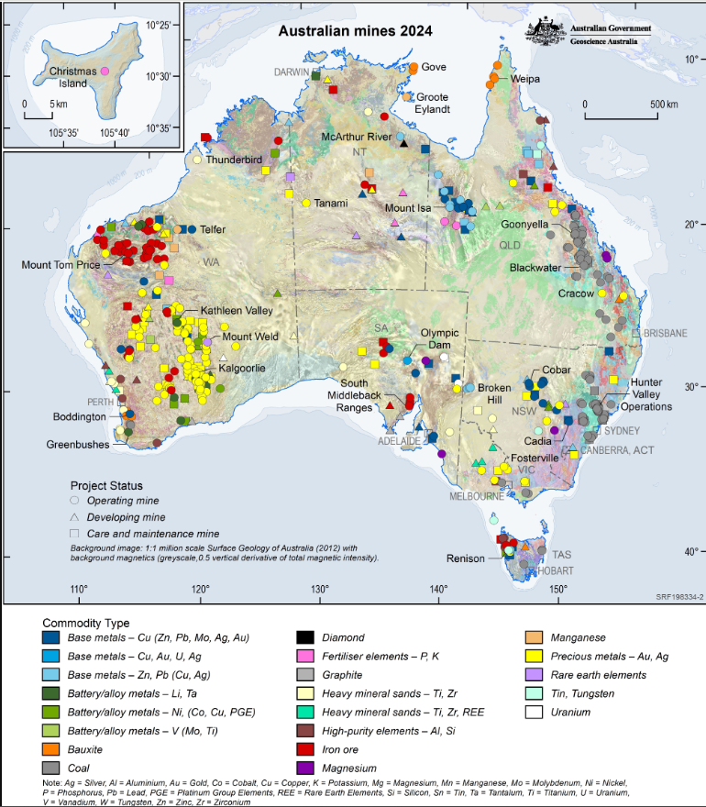
(Pheeney, J., Kucka, C., 2025 Australian Operating Mines Map 2024. Commonwealth of Australia (Geoscience Australia). https://dx.doi.org/10.26186/150112)

Using the Geosciences Australia map on the previous page, draw or colour the locations of the following commodities: coal, iron ore, aluminium (Al - Bauxite), copper (Cu), gold (Au), silver (Ag); and the critical minerals, lithium (Li), cobalt (Co), and manganese (Mn).

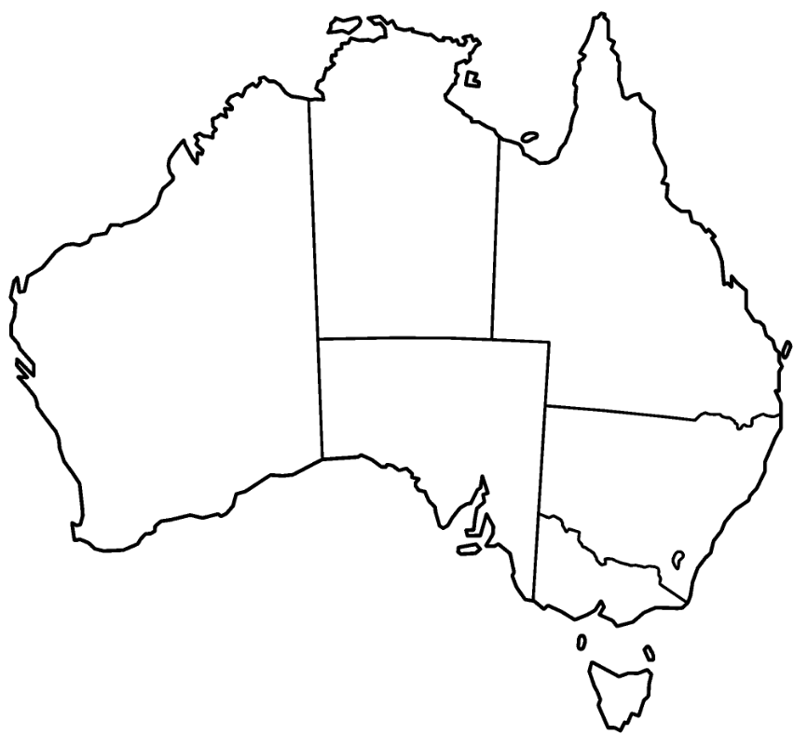

Use the table and tick the state in which each mineral is located.
 | Coal | Iron Ore | Copper | Gold | Silver | Aluminum

WA

NSW

QLD

NT

VIC

SA

TAS

ACT

What do you notice about the location of different minerals?

Research why different minerals are located in different regions of Australia.

Research why some minerals are considered critical or strategic materials.

Solutions

Use the map from Geosciences Australia above

Use the table and tick the state in which each mineral is located.
 | Coal | Iron Ore | Copper | Gold | Silver | Aluminum
WA | Y | Y | Y | Y | Y | Y
NSW | Y |  | Y | Y | Y
QLD | Y |  | Y | Y | Y | Y
NT |  | Y | Y | Y | Y | Y
VIC | Y |  |  | Y | Y | Y
SA |  | Y |  | Y | Y
TAS | Y | Y |  |  |  | Y

ACT

What do you notice about the location of different minerals?
A: Clusters of the same types of minerals.

Research why different minerals are located in different regions of Australia.
Australia's mineral deposits are closely linked to the geological history and formation of the continent. Here's a brief overview of some key minerals and their associated geological formations:
- Iron Ore: Major iron ore deposits in the Pilbara region of Western Australia are associated with the Hamersley Basin, which formed during the Archean Eon (around 3.6 to 2.5 billion years ago) through volcanic and sedimentary processes. These deposits are often found in banded iron formations (BIFs).

- Coal: Coal deposits in Queensland and New South Wales are primarily associated with sedimentary basins, such as the Bowen Basin and the Sydney Basin. These basins formed during the Paleozoic Era (around 541 to 252 million years ago) through the accumulation of organic-rich sediments in ancient swamps and lakes.

- Gold: Gold deposits in Australia are found in a variety of geological settings, including Archean greenstone belts (such as the Kalgoorlie region in Western Australia), Paleozoic volcanic belts (such as the Victorian Goldfields), and sedimentary basins (such as the Tanami Desert in Northern Territory). These deposits formed through a combination of volcanic, sedimentary, and hydrothermal processes.
- Lithium: Lithium deposits in Western Australia, particularly in the Greenbushes area, are associated with pegmatite dikes. These dikes formed during the Proterozoic Eon (around 2.5 billion to 541 million years ago) through the crystallization of molten rock (magma) rich in lithium and other rare elements.

- Copper: Copper deposits in Australia are found in a variety of geological settings, including volcanic-hosted massive sulfide (VHMS) deposits and sediment-hosted stratiform deposits (such as the Mount Isa deposit in Queensland). These deposits formed through a combination of volcanic, sedimentary, and hydrothermal processes.

- Nickel: Nickel deposits in Western Australia, particularly in the Kambalda region, are associated with komatiite volcanic rocks. These rocks formed during the Archean Eon through the eruption of lava with high magnesium and nickel content.
- Rare Earth Elements: Rare earth element deposits in Australia are associated with alkaline igneous rocks and carbonatites. These rocks formed during various geological periods, including the Archean, Proterozoic, and Paleozoic, through the crystallization of magma enriched in rare earth elements.
Overall, Australia's mineral deposits are diverse and reflect the complex geological history of the continent, which has experienced multiple episodes of tectonic activity, volcanic eruptions, and sedimentary deposition over billions of years.

Research why some minerals are considered critical or strategic materials.
Minerals are classified based on how essential they are to modern technologies and how secure their supply chains are:
- Critical Minerals: These minerals are vital for advanced technologies like batteries, renewable energy systems, and electronics, but their supply is at risk because they are rare, difficult to process, or concentrated in a few countries. In Australia, examples include lithium, cobalt, rare earth elements and graphite. If supply is disrupted, industries such as clean energy, telecommunications, and defence would face serious challenges.
- Low-Risk Minerals: Minerals like iron ore and bauxite are considered low-risk because they are abundant in Australia and globally, with stable and well-established supply chains. They remain important for construction and manufacturing but do not face the same vulnerability to supply disruptions as critical minerals.

Minerals At Home – Worksheet 2 Primary School

Where do minerals come from?
Minerals are the special ingredients that help to make things work. They are found in the Earth’s crust, and in ore (a type of rock that contains valuable minerals or metals inside). Australia is abundant in coal and minerals such as copper, silver, aluminium, and iron. These minerals are all used to make the objects that you use every day, such as your TV, tablet, and bicycle! If it lights up or turns on, it contains minerals that we mine in Australia. If it can’t be grown, it must be mined. Some minerals are considered extra special as their availability could be interrupted and this would impact the manufacture of electronics that we use in our day to day lives. These minerals are called critical minerals and there are many critical minerals mined in Australia. These critical minerals are used in all the electronic devices around your home.

How do we mine the minerals?

Process of Mining
Mining starts with exploration, which means searching for places where valuable minerals might be found. Scientists like geologists and geophysists use maps and special tools to find the best spots. Once they know where the minerals are, mining begins. This can be digging big open pits or making tunnels underground to reach the rocks. After the minerals are taken out, they go to processing plants where machines crush the rocks and separate the useful parts from the waste. Finally, when the mining is finished, workers do rehabilitation, which means fixing the land by planting trees, cleaning the water, and making the area safe for animals and people again.
Careers in Mining
Many different jobs are needed to make mining happen. First, geologists look for places where minerals might be found by studying rocks and maps. Then engineers design the mines and plan how to dig safely. Miners work in the pits or tunnels to take the minerals out of the ground. After that, workers in processing plants crush the rocks and separate the useful minerals. Finally, environmental scientists and rehabilitation teams help fix the land by planting trees and cleaning water so animals and people can use it again. All these jobs work together to make mining safe and responsible.

(Pheeney, J., Kucka, C., 2025 Australian Operating Mines Map 2024. Commonwealth of Australia (Geoscience Australia). https://dx.doi.org/10.26186/150112)

Activity
Colour the minerals, then cut and paste these mineral symbols on the map of Australia where they are found using the map above.
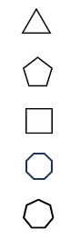

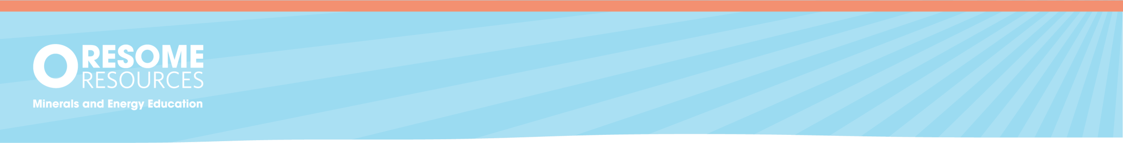

Minerals At Home –
Worksheet 2 Primary School
Shapes | Minerals
 | Gold
 | Copper
 | Coal
 | Bauxite
 | Iron

Reading comprehension
Use the background information to answer the following questions:
- What is gold used for?

- What is Iron ore used for?

- What is copper used for?

- What state or territory do you live in? Use both the map and background information to summarise the minerals that are located in your state.

Solutions
- What is Gold used for?
A: Gold is used to make jewellery and in electronics as it is resistant to tarnish and offers a superior level of electrical conductivity.

- What is Iron Ore used for?
A: Iron is a crucial material for making steel, used in construction and manufacturing industries globally. Iron ore is a major export material.

- What is Copper used for?
A: Copper is used in many things, especially electrical wire, as it is abundant and a great cost effective conductor for electronic devices.

- What state or territory do you live in? Use both the map and background information to summarise the minerals that are located in your state.

 | Coal | Iron Ore | Copper | Gold | Silver | Aluminum
WA | Y | Y | Y | Y | Y | Y
NSW | Y |  | Y | Y | Y
QLD | Y |  | Y | Y | Y | Y
NT |  | Y | Y | Y | Y | Y
VIC | Y |  |  | Y | Y | Y
SA |  | Y |  | Y | Y
TAS | Y | Y |  |  |  | Y

ACT

Minerals at Home – Worksheet 3

A sustainable future together: mining and recycling technologies

Mining critical minerals is more important than ever. We need minerals for constructing batteries that store carbon-neutral energy , building renewable energy sources like wind and solar power, and manufacturing electronic devices like smartphones. Any object that requires raw materials in its manufacture depends on minerals. However, there is a finite amount of minerals available to mine, so we must focus on sustainability by reducing the amount of materials we use in design and mining more efficiently.
Critical/Strategic Minerals Challenge
Individually or in groups develop answers for the following challenges and report back to your class. Focus on the current methods used and hypothesise new technologies that could help reduce the demand on the amount of critical minerals needed to manufacture new products.
- Copper: It’s in our wires and makes electricity flow. Research how copper is used in wires and electronics and hypothesise how we can use less copper or recycle old wires. Explore different electronic devices, and then as a group choose one device to research. Design a new way to reduce copper usage in that device without impacting on its function.

- Lithium: Lithium powers electric cars. Research how lithium is used in batteries and explain the current ways we recycle old batteries. Hypothesise new ways to make lithium extraction and processing more efficient. Finally, explore different ways we can use the ore more effectively and reduce waste.
- Rare Earth Elements: These are specialised minerals used in devices like phones and wind turbines. Research some examples and explain how we can use them wisely. EXTRA-CHALLENGE: Rare earth minerals are difficult to recycle, hypothesise new technologies that could make recycling possible.

Critical/Strategic Minerals Challenge - Example Responses
- Copper: It’s in our wires and makes electricity flow. Research how copper is used in wires and electronics and hypothesise how we can use less copper or recycle old wires.
Copper is a great conductor and electricity flows easily through copper metal. Copper is made into thin strands and covered in rubber or plastic to insulate the flow of electricity. Ideas for reduction and recycling copper:
- Change the design of electrical items using less wiring to reduce the amount needed.
- Explore using different materials when manufacturing electrical items.
- Lithium: Lithium powers electric cars. Research how lithium is used in batteries and explain the current ways we recycle old batteries. Hypothesise new ways to be more efficient at lithium extraction from old batteries.
Lithium is excellent at storing a large amount of energy in a small space. Lithium is removed from old batteries in a few different ways, a few are:
- crushing batteries into small pieces and removing the lithium
- chemical processing, which involves using chemicals to dissolve and remove the lithium
- electrochemical processing uses special equipment with a cell that attracts the lithium metal ion
- Rare Earth Elements: These are specialised minerals used in devices like phones and wind turbines. Research some examples and explain how we can use them wisely.
Extra-challenge: Rare earth minerals are difficult to recycle, hypothesise new technologies that could make recycling possible.
Rare earth metals are a group of metals that aren’t actually rare but found with other minerals and difficult to separate out. Examples are neodymium, cerium, and lanthanum. They are used in objects such as headphones, electric cars, batteries, hybrid cars, and electronic devices.
An idea for new technologies to recycle rare earth metals could be some type of new metal sorting machine which crushes the electronic devices and then collects the rare earth metals.

